Lab: Sets and Maps Advanced
This document defines the lab for the "Java Advanced" course @ Software University. Please submit your solutions (source code) to all below-described problems in Judge.

Sets

Parking Lot
Write a program that:
- Records car numbers for every car that enters the parking lot.
- Removes car number when the car is out.
When the parking lot is empty, print "Parking Lot is Empty".

Input
The input will be a string in the format "{direction, carNumber}".
The input ends with the string "END".

Output
Print the output with all car numbers which are in the parking lot.

Examples
Input | Output
IN, CA2844AA  IN, CA1234TA  OUT, CA2844AA  IN, CA9999TT  IN, CA2866HI  OUT, CA1234TA  IN, CA2844AA  OUT, CA2866HI  IN, CA9876HH  IN, CA2822UU  END | CA9999TT  CA2844AA  CA9876HH  CA2822UU
IN, CA2844AA  IN, CA1234TA  OUT, CA2844AA  OUT, CA1234TA  END | Parking Lot is Empty

Hints
- Car numbers are unique.
- Use the methods isEmpty().

SoftUni Party
There is a party in SoftUni. Many guests are invited, and they are two types: VIP and regular.
When a guest comes, you have to check if he/she exists on any of the two reservation lists. All reservation numbers will be with 8 chars. All VIP numbers start with a digit.
There will be 2 command lines:
- First is "PARTY" - the party is on, and guests are coming.
- The second is "END" - then the party is over, and no more guests will come.
The output shows all guests who didn't come to the party (VIP must be first).

Examples
Input | Output | Input | Output
7IK9Yo0h  9NoBUajQ  Ce8vwPmE  SVQXQCbc  tSzE5t0p  PARTY  9NoBUajQ  Ce8vwPmE  SVQXQCbc  END | 2  7IK9Yo0h  tSzE5t0p | m8rfQBvl  fc1oZCE0  UgffRkOn  7ugX7bm0  9CQBGUeJ  2FQZT3uC  dziNz78I  mdSGyQCJ  LjcVpmDL  fPXNHpm1  HTTbwRmM  B5yTkMQi  8N0FThqG  xys2FYzn  MDzcM9ZK  PARTY  2FQZT3uC  dziNz78I  mdSGyQCJ  LjcVpmDL  fPXNHpm1  HTTbwRmM  B5yTkMQi  8N0FThqG  m8rfQBvl  fc1oZCE0  UgffRkOn  7ugX7bm0  9CQBGUeJ  END | 2  MDzcM9ZK  xys2FYzn

"Voina" – Number Game
Write a program that:
- Reads 20 numbers for both players, separated with " " (single space).
- Every player can hold unique numbers.
Each Round, both players get the top number from their deck. The player with the bigger number gets both numbers and adds them to the bottom of his sequence.
The game ends after 50 rounds or if any player loses all of his numbers.

Input
- Numbers – Integer

Output
- Output must be "First player win!", "Second player win!" or "Draw!".

Examples
Input | Output
26 58 16 92 44 65 65 77 57 23 71 57 7 52 85 44 32 70 38 23  43 95 33 51 62 93 57 55 0 31 32 95 68 34 30 51 37 32 11 97 | Second player win!
74 78 82 42 19 39 29 69 20 42 31 77 57 36 76 26 4 9 83 42  15 43 80 71 22 88 78 35 28 30 46 41 76 51 76 18 14 52 47 38 | First player win!

Hints
- Use Iterator<E> and next() for finding the top number in decks.
- Think where to check if any player is without cards.
- When you find the top number, be sure to remove it immediately.

Solution
You might help yourself with the code below:
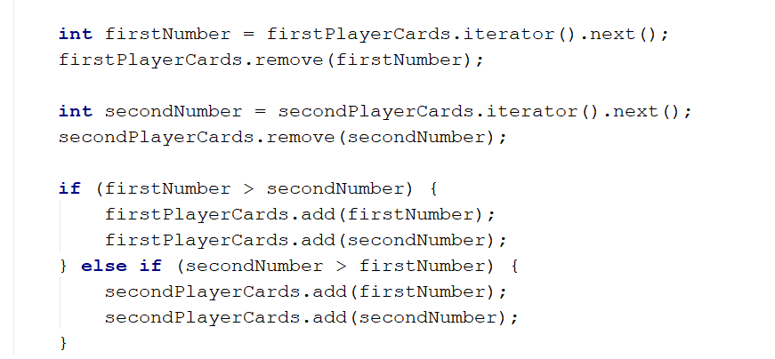

Maps

Count Real Numbers
Write a program that counts the occurrence of real numbers. The input is a single line with real numbers separated by a space. Print the numbers in the order of appearance. All numbers must be formatted to one digit after the decimal point.

Examples
Input | Output
-2.5 4 3 -2.5 -5.5 4 3 3 -2.5 3 | -2.5 -> 3  4.0 -> 2  3.0 -> 4  -5.5 -> 1
2.3 4.5 4.5 5.5 5.5 2.3 3.0 3.0 4.5 4.5 3.0 3.0 4.0 3.0 5.5 3.0 2.3 5.5 4.5 3.0 | 2.3 -> 3  4.5 -> 5  5.5 -> 4  3.0 -> 7  - -> 1

Solution
You might help yourself with the code below:
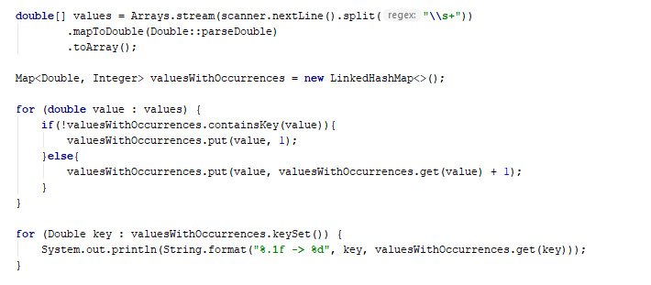

Average Students Grades
Write a program, which reads the name of a student and their grades and adds them to the student record, then prints grades along with their average grade – ordered the output by the students' names.

Input
On the first line N – the number of students, then on the next, N lines student name with grade.

Examples
Input | Output
7  Stephan 5.20  Maria 5.50  Stephan 3.20  Maria 2.50  Alex 2.00  Maria 3.46  Alex 3.00 | Alex -> 2.00 3.00 (avg: 2.50)  Maria -> 5.50 2.50 3.46 (avg: 3.82)  Stephan -> 5.20 3.20 (avg: 4.20)
4  Alex 4.50  Peter 3.00  Alex 5.00  Peter 3.66 | Alex -> 4.50 5.00 (avg: 4.75)  Peter -> 3.00 3.66 (avg: 3.33)
5  George 6.00  George 5.50  George 6.00  Alex 4.40  Peter 3.30  Peter 4.50 | Alex -> 4.40 (avg: 4.40)  George -> 6.00 5.50 6.00 (avg: 5.83)  Peter -> 3.30 (avg: 3.30)

Hints
- Use a TreeMap (String -> ArrayList<Double>).
- Check if the name exists before adding the grade. If it doesn't, add it to the map.
- Pass through all key-value pairs in the map and print the results.
- Think of a way to get the average grades for each student.
- You can do that with an ordinary loop or with Stream API.

Product Shop
Write a program that prints information about food shops in Sofia and the products they store. Until the "Revision" command you will receive an input in the format: "{shop}, {product}, {price}".
Keep in mind that if you get a store that already exists, you must gather product information.
Your output must be ordered by shop name and must be in the format:
"{shop}->
Product: {product}, Price: {price}"
The price should be formatted to one digit after the decimal point.

Examples
Input | Output
lidl, peach, 1.20  lidl, juice, 2.30  fantastico, apple, 1.20  kaufland, banana, 1.10  fantastico, grape, 2.20  Revision | fantastico->  Product: apple, Price: 1.2  Product: grape, Price: 2.2  kaufland->  Product: banana, Price: 1.1  lidl->  Product: peach, Price: 1.2  Product: juice, Price: 2.3
tmarket, peanuts, 2.20  GoGrill, meatballs, 3.30  GoGrill, HotDog, 1.40  tmarket, sweets, 2.20  Revision | GoGrill->  Product: meatballs, Price: 3.3  Product: HotDog, Price: 1.4  tmarket->  Product: peanuts, Price: 2.2  Product: sweets, Price: 2.2

Cities by Continent and Country
Write a program to read continents, countries, and their cities put them on a nested map, and print them in the order of their first appearance.

Examples
Input | Output
9  Europe Bulgaria Sofia  Asia China Beijing  Asia Japan Tokyo  Europe Poland Warsaw  Europe Germany Berlin  Europe Poland Poznan  Europe Bulgaria Plovdiv  Africa Nigeria Abuja  Asia China Shanghai | Europe:  Bulgaria -> Sofia, Plovdiv  Poland -> Warsaw, Poznan  Germany -> Berlin  Asia:  China -> Beijing, Shanghai  Japan -> Tokyo  Africa:  Nigeria -> Abuja
3  Europe Germany Berlin  Europe Bulgaria Varna  Africa Egypt Cairo | Europe:  Germany -> Berlin  Bulgaria -> Varna  Africa:  Egypt -> Cairo
8  Africa Somalia Mogadishu  Asia India Mumbai  Asia India Delhi  Europe France Paris  Asia India Nagpur  Europe Germany Hamburg  Europe Poland Gdansk  Europe Germany Danzig | Africa:  Somalia -> Mogadishu  Asia:  India -> Mumbai, Delhi, Nagpur  Europe:  France -> Paris  Germany -> Hamburg, Danzig  Poland -> Gdansk

Hints
- Use a nested Map (String -> (Map -> ArrayList<String>)) .
- Check if the continent exists before adding the country. If it doesn't, add it to the dictionary.
- Check if the country exists before adding the city. If it doesn't, add it to the dictionary.
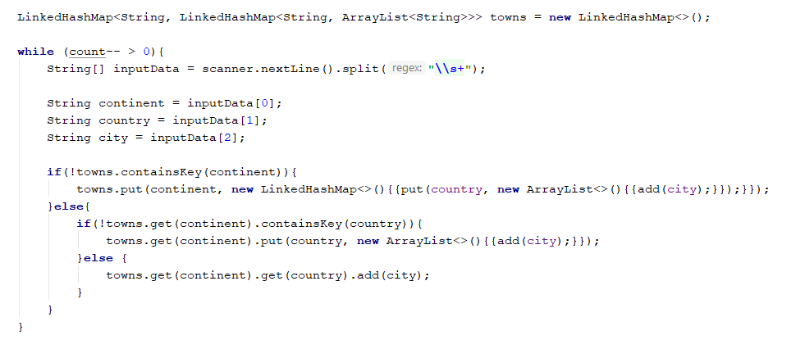
- Pass through all key-value pairs in the Map and the values' key-value pairs and print the results.

Academy Graduation
Write a program that:
- Reads from console number of students for a track.
- Reads on pair of rows:
  - The first line is the name of the student.
  - The second line is his score for a different number of courses.
- Print on console "{name} is graduated with {average scores)".

Examples
Input | Output
3  George  3.75 5  Maria  4.25 6  Peter  6 4.5 | George is graduated with 4.375  Maria is graduated with 5.125  Peter is graduated with 5.25
5  George  4.36 5.50 3.30 5.63 2.57 5.75 2.81 4.89  Peter  3.10 5.35 3.30 3.35 5.64 4.99 2.75 4.68  Maria  3.45 3.23 3.03 5.42 5.46 4.15 2.26 5.95  Rosalia  2.08 3.48 3.36 2.73 2.96 4.54 3.70 3.85  John  4.75 4.92 3.78 4.79 4.82 4.75 2.81 2.13 | George is graduated with 4.351249999999999  John is graduated with 4.09375  Maria is graduated with 4.11875  Peter is graduated with 4.145  Rosalia is graduated with 3.3375

Hints
- Think about the proper type of map.
- Value can be an array.
- A nested loop and one more variable will be needed for the average score.

Solution
You might help yourself with the code below:
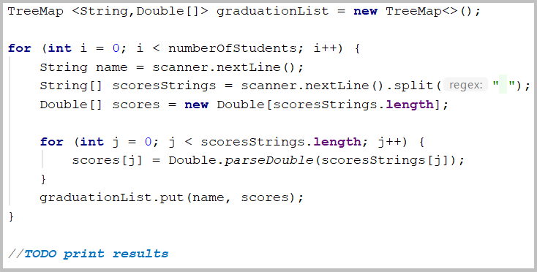

Largest 3 Numbers
Read a list of integers and print the largest 3 of them. If there are less than 3, print all of them.

Examples
Input | Output
10 30 15 20 50 5 | 50 30 20
20 30 | 30 20

Hints
- Read a list of integers.
- Order the list using Stream API.
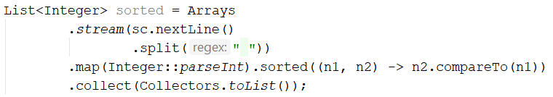
- Print top 3 numbers with for loop.

